Humanoid Arm and Hand

**Appendix 3 – Full Literature Review from Jack Hodgson**

Literature and Technology Review

Jack Hodgson

ENGEN582

Abstract

In this literature and technology review the common design concepts of a humanoid arm and hand are investigated. It was found that the human arm can be approximated using a 7-DOF system. It was also found that the hand is where it is much more complicated and very hard to recreate the exact motions and capabilities of the human hand in a cost effective and controllable way. Common designs include hands that are controlled through mechanically linkages between joints or with tendons that are pulled by motors either in the hand, or larger motor placed in the forearm, more representative of the human anatomy. Dual mode mechanisms to increase joint speed and output force were found and discussed.

## Introduction / Purpose

The aim of this literature and technology review was to answer some key questions and get an overview on where current technology is. This review is part of project to design and build a pair of humanoid arms and hands with a control system to allow do complex tasks such as play the piano and pour a glass of water. The project proposal for said project can be seen appended in Appendix A.

The main questions to be answered are;

How are the human joints approximated?

How many DOF does each joint require?

What are the key trade-offs between actuation speed and strength?

What do power sources are typically used?

This review will focus more on the mechanical design the arm rather than different control methods used to control the arm.

## Technology Use Cases

Humanoid arm technology is becoming a heavily studied field of robotics and has many possible use case in a wide range of fields from the medical industry to space exploration (UNIVERSAL ROBOTS, 24 C.E.).

For example, humanoid hands are used to durability test astronauts space gloves over long periods of time and with a highly comparable motion to that expected by a human (Bai et al., 2022).

Humanoid arms could also play a large role in safety critical applications where the risk involve is not suitable to be carried out by a human, this may be the handling of radioactive materials (Lee & Cho, 2023) or humanoids designed for the use in complex rescue operations (Sun et al., 2022).

Arm Design

The design of the arm, however not as space limited as a hand, is still extremely critical to the overall dexterity and easy of control of the overall arm. A arm with too few DOF will have a limited range of motion and may not be suitable to a range of different tasks, however, too many DOF will result in an over complex and hard to manipulate arm, it will also likely cause it to be heavy and slow moving. The overall strength of the materials and joint designs used is especially crucial further up the arm towards the elbow and shoulder joint. There has been significant research over the years into the optimal DOF of each joint in order to successfully mimic the motion of human arm, while maintaining strength and ease of control.

Shoulder Joint

The shoulder joint in a human is a ball joint controlled by many complexly positioned muscles, (Singleton, 1966). This anatomy is extremely hard to mechanically replicate in a robotic sense, and is typically simplified and split into separate joints.

In (Zhu et al., 2023), the paper looked at a 7-DOF arm to actuate a steering wheel. The arm contains a 3-DOF shoulder which is split into 3 separate joints, with a combined mass of approximately 5.6 kg.

This design uses three frameless DC motors which are structurally built into each joint without the need for gears or other power transmission means.

In order to make the arm as lightweight as possible, the design include sections of the arm framing that do not have a smooth and continuous surface. This aids in performance, however it does take away from the humanoid aspect, possibly a lightweight outer shell could have been added to remove the holes in the design.

In (Wang et al., 2023), a 7 DOF arm, including a 3 DOF shoulder joint is designed based on the principle of an anti-parallelogram mechanism. The shoulder joint can be seen in Figure 1. This design uses Bowden cables to transmit power from a power source, such a DC motor, from the base through the sheaths and into each joint. There are multiple advantages to using such a design, the biggest one an extremely light weight arm with no need for power sources inside any moving parts. Also due to this, the power source powering the Bowden cables are not as restricted in size and weight like in a traditional design, this allows for extra strength and speed to be integrated by using larger and more powerful motors. The key disadvantage is this concept would not be easily integrated into a complete humanoid robot as this design relies heavily on the base where the arm is attached to being large and fixed in place. Integrating the arm motors into a moving robotic torso eliminates many of the advantages of the initial design.

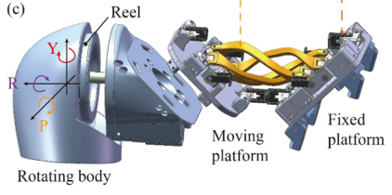

Figure 1. (Wang et al., 2023)

The paper (Zhu, Bai, et al., 2023), claimed that despite the human arm being able to be simplified to a 7-DOF hybrid mechanism, this number of degrees of freedom has a complicated inverse kinematic solution and is hard to control. Instead, the paper introduced a 4-DOF centrally driven humanoid robotic arm, seen in Figure 2. To reduce the complexity of the shoulder joint, the arm was split into a 2-2 configuration, with both the shoulder and elbow joint having two degrees of freedoms each. Each DOF is controlled by a single motor, all four of which are positioned within the shoulder joint. The first two motors directly power the joints within the shoulder, while the power for the elbow is transmitted through the 4 bar linkage mechanism seen in Figure 2, connecting the two joints. Two of the connecting bars are s-shaped, this is to reduce interference.

The paper claims that due to this design the total initial of the arm is reduced compared to a traditional 7-DOF and therefore increase the possible movement speed. Although, due to a significant further number of degrees of freedom, the range of use cases and tasks completable by this arm would be greatly smaller, this is a field in which was not investigated within this paper.

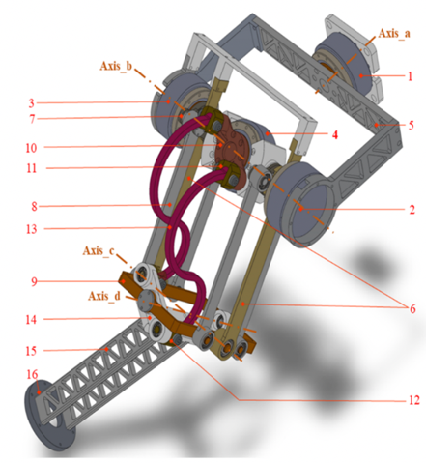

Figure 2. (Zhu, Bai, et al., 2023)

In (Lee & Cho, 2023), the paper investigates a humanoid arm design and control system to steer a steering wheel. In which is suggested that significant research has been done into 6 and 7-DOF humanoid arms although they claim that these arms have geometric and structural limitations for complex multitasking that humans can easily do. They also suggest that there has not been enough research into higher DOF systems to claim that they are redundant. This paper investigates a 9-DOF humanoid arm, with a 5-DOF shoulder, seen in Figure 3.

Like the shoulder described in (Zhu et al., 2023), the design uses the 3-DOF ball joint approximation but with two extra degrees of freedom added to the base of the shoulder in the collarbone region. This paper claims for complex tasks such as turning a steering wheel smoothly, scapulohumeral rhythm is required. Through experimentation, they claim that the added DOF within the shoulder joint increased the versatility of the arm as well as increasing the workspace for bimanual tasks with both two arms compared to a pair of arms with 6 or 7-DOF. It was mentioned that they came across tracking relation problems while conducting the experiments, which is an expected consequence of added complexity and DOF.

Figure 3. (Lee & Cho, 2023)

In the paper (Min et al., 2020), they claim powerful actuators increase cost of robots, therefore they developed a 6-DOF arm which contained a 4-DOF counter balancing mechanism which reduced torque requirements by 60%.

Elbow Joint

Of all joints in the human arm, the elbow joint is the least variable in terms of robotic design. The vast majority of humanoid arms designed use a single DOF joint, and there is little variation on a lot of designs.

In (Wu et al., 2023), a humanoid arm control method was developed on a 7-DOF humanoid arm which contained a 1-DOF elbow joint. The elbow joint is powered by a single motor which is structurally built into the joints frame, as seen in Figure 4. This appears to be the most common solution to this specific joint as can also be seen in the arm in (Lee & Cho, 2023), and (Zhu et al., 2023).

Figure 4. (Wu et al., 2023)

In (Mori et al., 2019), a humanoid arm is developed for use as a high speed robotic arm configured to play badminton. This arm features are much more unique design in terms of humanoid arms with the use of pneumatic-electric hybrid actuators. Initially, the arm had purely pneumatic control, although it was found that it while pneumatic control was used for gravity compensation it was not enough for a dynamic swing. With the hybrid system it was found to be 3.3 times more accurate compared to the pneumatic control.

The arm achieved a maximum racquet speed of 19 m/s and is 6.3 kg.

The designed arm is much larger other humanoid arms discussed which include DC motors. Using pneumatics allows for high speed articulation, although its use cases are limited due to the overly large nature and un-human like form. Also, in terms of the elbow joint, a power source which provides rotational work does not require extra mechanical components achieve the desired motion, whereas a linear source like pneumatics does, which as seen in this design requires extra complexity.

Ulna-Radius

In the human arm, the forearm can twist as the radius and ulna bones cross over each other (HAERLE et al., 2003). Although this is not a physical joint within the human arm, this motion can be approximated by a rotation joint in the forearm, between the wrist and elbow. This joint can be seen in nearly all humanoid arms, with minimal changes between designs.

In (Tomić et al., 2018), the paper investigated the conversion of human like motion to a form of control of a humanoid. They humanoid that was used, ROMEO, has 7 DOF is the arm which includes one DOF from what is referred to as the “elbow yaw” joint. It was found that the elbow yaw joint, along with the other DOF were necessary in accurately replicate human like motion.

In (Dou et al., 2022), the inverse kinematics of a 7-DOF humanoid arm was investigated. This arm has an integrated elbow and radioulnar syndesmosis creating a 2 DOF module. The design includes two motors which control both joints simultaneously through the use of cables and pulleys, as seen in Figure 5. The first motor is located outside of the module while the second is inside the module and spins with the joints rotation, the paper claims this shortens the cable transmission distance and therefore increases the end point accuracy of the hand.

Figure 5. (Dou et al., 2022)

In (Rubies et al., 2023), a control system was designed for a humanoid to perform arm gestures. The chosen humanoid in this paper does not have this DOF in the forearm. Despite this, it was argued that for the application, exact human motion was not needed to be imitated, and the rotational position of the hand was irrelevant.

Wrist Joint

The human wrist joint, like the shoulder, is a mechanically complex joint in which there has been extensive research into different solutions to mimic the human joint. Most of which can be split into three main categories.

The first and most simple would be a fixed wrist. This can be seen in this design (Johansson et al., 2020). This wrist is simply fixed in position with no movement where it is argued that the additional benefits of a moving wrist are not worth the complexity sacrifice and can many motions can be generated either through movement in the arm or from the fingers.

In (Yin et al., 2022), a 6-DOF with a 1-DOF wrist joint. In this paper they investigated the control strategy of flexible joints driven by tendons which are carried within a tendon-sheath. They found that the tendon-sheath flexibility affected the joint speed as well as the positional accuracy decreasing and manipulator vibration.

This shows that tendons that require to travel though joints require significant control optimisation, which when using tendons for finger actuation that need to pass through the wrist and into the forearm, the complexity of this joint should be considered from this perspective.

To best mimic the motions of a human hand in (Averta, 2022), a wrist joint was designed using 2 DOF. This designs feature what they refer to as a “soft wrist joint” seen in Figure 6, where the two DOF are separated into two modules, one being for Pronation and Supination and the second is for Abduction-Adduction, whereas typically the 1 DOF wrists only have Abduction-Adduction. This design despite having 2 DOF only requires one motor to operate both functions, which significantly reduces the space required, and therefore is somewhat space competitive with other designs above which only have one DOF.

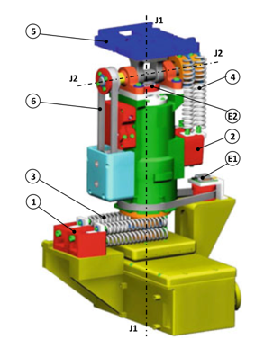

Figure 6. (Averta, 2022)

Another example of a 2 DOF wrist joint concept is the design featured in (Jiang et al., 2017). This design uses a base plate connected to the an upper plate via a spring and three wires as seen in Figure 7. Three DC motors control the wires therefore controlling the position of the upper platform in 2 dimensions. This is a significantly different approach to many other join designs by combining the different DOF into one joint. Although, despite the paper mentioning it could be used as a wrist joint the design is quite large and hasn’t been optimised to fit within the constraints of a human forearm (for use in wrist joint). Also the design uses there large motors for a 2 DOF joint. In a space constrained application such as a humanoid arm this is a key concern and considering the design in (Jiang et al., 2017), only uses one motor this appears to be a inferior design for a humanoid wrist joint.

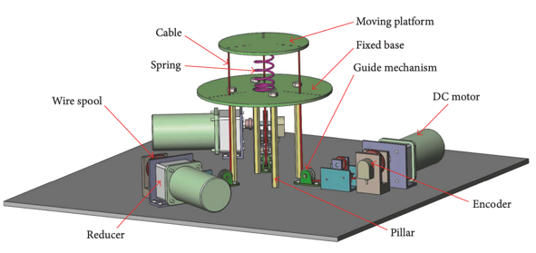

Figure 7. (Jiang et al., 2017)

## Hand Design

Finger Joints

Human fingers are have three main joints, MCP, PIP and DIP (Jiang et al., 2017). To simplify the already very complex problem, some humanoid robotic hands eliminate the final DIP joint at the top of finger and replace it with either, a fixed angled fingertip or simply extend the middle phalange to span the length of the finger. While some designs feature all three moveable joints.

The fixed DIP joint can be seen on the Tesla Optimus bot (Tesla, 2024). This approach limits the range of motion of the fingers and also limits the grip types achievable, however it creates room to add large pressure sensors to the tips of the fingers, as seen in the Tesla bot, which is not as simple in a finger using a movable DIP joint.

The 3D printed fingers used in (Johansson et al., 2020), and (Prabhu et al., 2021), have similar design concepts which both include the DIP joint.

In some cases this third joint is necessary due to the use case, for example the goal of the hand designed in (Bai et al., 2022), is to test the flexibility and durability of spacesuit gloves while mimicking the motions of a human hand. To achieve this the hand must have all the degree of freedom that a human has, therefore requiring this DIP joint.

In (Xia et al., 2019), the design of the hand involves adding addition DOF in each finger through the use of the IP joint. This allows side to side motion of the finger as shown in Figure 8. This hand also has an additional DOF in the little finger which recreates the cupping of the palm motion. This extra DOF in the little finger/palm is crucial for perfecting certain grip types laid out below. This hand also contains encoders in each of the fingers joints to measure the angle of each joint and therefore position of finger.

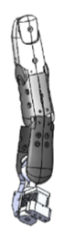

Figure 8. (Xia et al., 2019)

From these examples it can be seen that a simple finger containing a MCP and PIP join can create a functional hand, however for added dexterity and similarity to a human hand, the DIP joint is beneficial. Finally, at an expensive of major complexity, further degrees of freedom can be added to each finger to create a highly biometrically accurate and dexterous hand that can replicate the a significant portion of movement of a real hand. Although, a perfect replica is not necessarily achievable. As argued in (Szkopek & Redlarski, 2019), hands with less than 16 total DOF lose dexterity, while hands with over 19-DOF are the most sophisticated group of artificial hands.

Finger Actuation

Actuation of the fingers in robotic hands are extremely important for the useability and function of the final product. The finger must have enough grip strength in a variety of grip types depending on the use case while also having a large range of motion which can be covered quickly.

Typically fingers in robotic hands are either mechanically driven via linkages or with a single fixed point tendon. As explained by (Zhang et al., 2023), these approaches can result in highly dexterous robotic hands that are capable of a range of grasping actions on objects according to their size, shape and position. As laid out in, (Feix et al., 2016), the different grip types that are most important to accurately mimic a human hand can be seen in Figure 9.

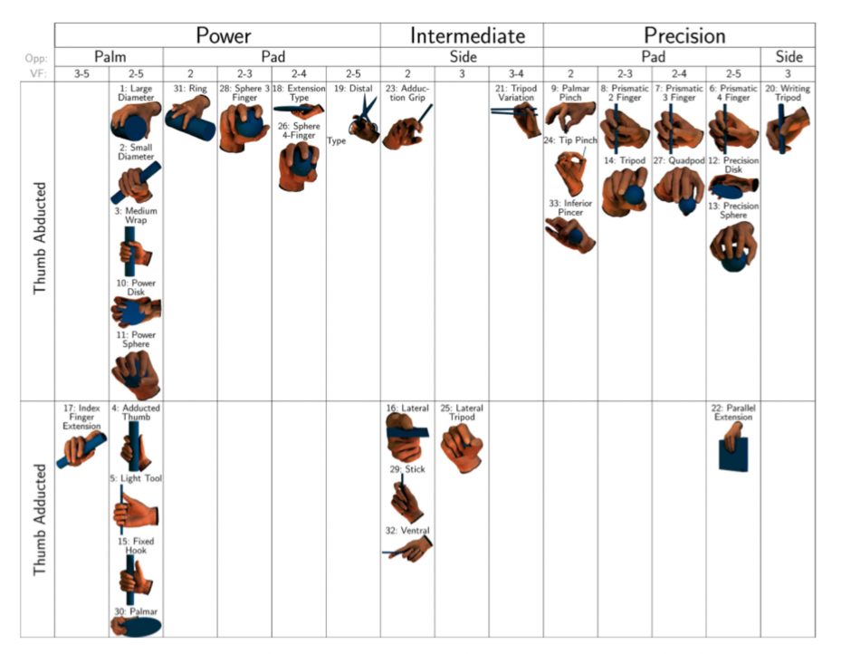

Figure 9. (Feix et al., 2016)

The hand used in (Xia et al., 2019), is a tendon driven hand powered by a linear stepper motor. This design uses two tendons, a tensioning and relaxer tendon. Because a tendon only works in tension, as opposed to a mechanical linkage which can work both ways under tension and compression (pull and push), in order to relax the gripping motion of each finger (straighten the fingers), a second tendon is used. This solution is similar to the tendons in a human finger. However, this solution is seen as unnecessary by some as it adds a redundant tendon which can be replaced with a torsion spring which returns the finger to a neutral position when tension in the tendon is released.

This solution can be seen in the paper, (Khusnutdinov et al., 2019, pp. 139–149). In the paper, (Johansson et al., 2020), a stiff rubber tendon is used which allows the tendon to work in slight compression and therefore does not require any additional components to relax the fingers to a neutral position. Another design feature is each tendon is controlled by the same motors, simplifying the design and space requirements. However, this solution has some major drawbacks, firstly the rubber tendons are likely to stretch under load reducing the accuracy in the position of each finger. Also, because only one motor is controlling every finger, the hand extremely limited by the number of grips possible. Finally, due to the limiting strength of rubber, the grip strength of the hand will limit the uses for a such a design.

With a design as seen in (Wu et al., 2023), which contains mechanical links between each finger joint, it can be seen that grip type 10, power disk, cannot be achieved due to the fact that each finger joints position is dependent on the previous, therefore a grip type where the DIP and PIP and clinched while the MCP is not is not possible.

As mentioned in (Zhang et al., 2023), another drawback to a mechanical linkage is there is often a major sacrifice in either finger speed or strength, as to achieve a high grip strength without using an overpowered and therefore unviable motor, high torque is required which will physically limit the speed at which the finger move under no load.

The design in (Zhang et al., 2023), Figure 10, addresses this through he use of a hybrid of the two concepts, a mechanical linkage for high torque and tendon driven for quick movements. Due to the hybrid design however, the fingers are noticeably larger and less human looking compared to many other designs covered while also lacking the DIP joints in each finger. Furthermore this paper only tested the finger individually, so while the design is seen to be able recreate a range of different finger grips, it is yet to be seen whether it can form the claimed grips with a fully integrated hand. To add to this, this paper did not mention how the concepts would be applied to a thumb, which for nearly every grip type listed above is a critical aspect.

Figure 10. (Zhang et al., 2023)

In (Takaki et al., 2006), a 5-bar CVT mechanism was investigated with the aim to solve the compromise mentioned above with respect to speed verses strength. The designed CVT (Continuously Variable Transmission) was found to allow the finger to exert over 100 N at the fingertip while rotating at 550 degrees per second under no load. These result they claimed would be impossible without such a design.

Similar to that in (Takaki et al., 2006), the paper (Shin et al., 2012), looked at a dual mode finger actuation method, one for fast movement speed and one for large grasping force both using a single motor. This method uses two parallel strings acting as tendons as seen in Figure 11. When in the high force mode, the strings are twisted around each other, which causes a decrease in length, and therefore a higher force within the strings. The deployment of each mode is governed by a brake located They found the method, depending on the operation mode made the finger 12.1 times faster and resulted in a fingertip force 4.61 times larger than the baseline design. This method had a mass of 29.9 g which is significantly smaller than the CVT design which had a mass of 99g, although the downside is it uses discrete modes, and therefore is not in an optimal setup at all times as opposed to the CVT design.

Figure 11. (Shin et al., 2012)

Thumb Design

As seen in Figure 9, many grip types are heavily dependent on the thumb to have a large range of motion. In (Johansson et al., 2020), the design used a fixed thumb, which servilely limits the functionality of the hand making its use cases very minimal, however it greatly reduces the complexity of the hand while retaining some functionality.

In (Huang & Huang, 2019), a 4-DOF thumb is developed as a chess playing robot, capable of picking up and placing chess pieces, a task in which a highly dexterous thumb is required. Figure 12, shows the axis of rotation in which the 4 degrees are freedom the thumb has.

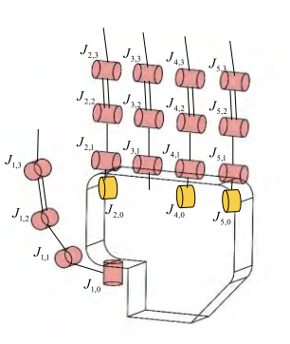

Figure 12. (Huang & Huang, 2019)

This design is still only an approximation of the human thumb movement, as it has 5 degrees of freedom. With only 4-DOF the thumb is not fully capable of true opposition of each finger, however for much applications this design is more than suitable.

The Schunk SVH 5-finger humanoid hand investigated in the paper, (Tieck et al., 2021), has only two degrees of freedom within the thumb, yet is capable of various grip types including holding bottles, different sized balls etc.

Conclusion

This review looked into the key design aspects of a humanoid arm and hand. It was found the most common arm design features 7-DOF, split into 3 or 4 main joints. The shoulder, which typically has 3-DOF, the elbow which typically has 1-DOF, the radius-ulna joint which has 1-DOF (commonly grouped with the elbow joint), and the wrist which has 2-DOF. This is the most common design but there are many other combinations, mainly simpler design with fewer degrees of freedom, however there are some which add complexity, typically to the shoulder.

The hand was found to have two common configurations, one being mechanically linked finger joints, and the second being tendon driven. Both have advantages and disadvantages, notably tendon driven can place motors further away from the fingers in order to make room for larger more powerful motors, however are typically less positionally accurate than the mechanically linked drive system.

**Appendix 4 - Project Proposal (Following Page)**

References

Averta, G. (2022). Using Nature-Inspired Principles to Design of Robotic Limbs: The Soft Wrist. *Springer Tracts in Advanced Robotics*, *145*, 95–111. https://doi.org/10.1007/978-3-030-92521-5_5

Bai, R., Kang, R., Shang, K., Yang, C., Tang, Z., Wang, R., & Dai, J. S. (2022). A humanoid robotic hand capable of internal assembly and measurement in spacesuit gloves. *Industrial Robot*, *49*(4), 603–615. https://doi.org/10.1108/ir-09-2021-0205

Dou, R., Yu, S., Li, W., Chen, P., Xia, P., Zhai, F., Yokoi, H., & Jiang, Y. (2022). Inverse kinematics for a 7-DOF humanoid robotic arm with joint limit and end pose coupling. *Mechanism and Machine Theory*, *169*, 104637. https://doi.org/10.1016/j.mechmachtheory.2021.104637

Feix, T., Romero, J., Schmiedmayer, H.-B., Dollar, A. M., & Kragic, D. (2016). The GRASP Taxonomy of Human Grasp Types. *IEEE Transactions on Human-Machine Systems*, *46*(1), 66–77. https://doi.org/10.1109/thms.2015.2470657

HAERLE, M., SCHALLER, H. E., & MATHOULIN, C. (2003). Vascular Anatomy of the Palmar Surfaces of the Distal Radius And Ulna: Its Relevance to Pedicled Bone Grafts at the Distal Palmar Forearm. *Journal of Hand Surgery*, *28*(2), 131–136. https://doi.org/10.1016/s0266-7681(02)00279-6

Huang, M.-B., & Huang, H.-P. (2019). Innovative Human-Like Dual Robotic Hand Mechatronic Design and its Chess-Playing Experiment. *IEEE Access*, *7*, 7872–7888. https://doi.org/10.1109/access.2019.2891007

Jiang, L., Gao, B., & Zhu, Z. (2017). Design and Nonlinear Control of a 2-DOF Flexible Parallel Humanoid Arm Joint Robot. *Shock and Vibration*, *2017*, 1–14. https://doi.org/10.1155/2017/2762169

Johansson, B., Tjøstheim, T. A., & Balkenius, C. (2020). Epi: An open humanoid platform for developmental robotics. *International Journal of Advanced Robotic Systems*, *17*(2), 172988142091149. https://doi.org/10.1177/1729881420911498

Khusnutdinov, K., Sagitov, A., & Yakupov, A. (2019). *Interactive Collaborative Robotics* (Vol. 11659, pp. 139–149). Springer International Publishing.

Lee, J., & Cho, B.-K. (2023). Design of 9-DOF humanoid arms inspired by the human’s inner shoulder to enhance versatility and workspace. *Robotics and Autonomous Systems*, *166*, 104447–104447. https://doi.org/10.1016/j.robot.2023.104447

Min, J.-K., Kim, D.-W., & Song, J.-B. (2020). A Wall-Mounted Robot Arm Equipped With a 4-DOF Yaw-Pitch-Yaw-Pitch Counterbalance Mechanism. *IEEE Robotics and Automation Letters*, *5*(3), 3768–3774. https://doi.org/10.1109/lra.2020.2975731

Mori, S., Tanaka, K., Nishikawa, S., Ryuma Niiyama, & Kuniyoshi, Y. (2019). High-Speed Humanoid Robot Arm for Badminton Using Pneumatic-Electric Hybrid Actuators. *IEEE ROBOTICS and AUTOMATION LETTERS*, *4*(4), 3601–3608. https://doi.org/10.1109/lra.2019.2928778

Prabhu, M. K., Sivaraman, P., Vishnukaarthi, M., Shankara Narayanan, V., Raveen, S., & Keerthana, G. (2021). Humanoid gesture control arm with manifold actuation using additive manufacturing. *Materials Today: Proceedings*, *37*, 717–722. https://doi.org/10.1016/j.matpr.2020.05.724

Rubies, E., Ricard Bitriá, Eduard Clotet, & Jordi Palacín. (2023). Remote Control Device to Drive the Arm Gestures of an Assistant Humanoid Robot. *Applied Sciences*, *13*(19), 11115–11115. https://doi.org/10.3390/app131911115

Shin, Y. J., Lee, H. J., Kim, K.-S., & Kim, S. (2012). A Robot Finger Design Using a Dual-Mode Twisting Mechanism to Achieve High-Speed Motion and Large Grasping Force. *IEEE Transactions on Robotics*, *28*(6), 1398–1405. https://doi.org/10.1109/tro.2012.2206870

Singleton, M. C. (1966). Functional Anatomy of the Shoulder. *Physical Therapy*, *46*(10), 1043–1051. https://doi.org/10.1093/ptj/46.10.1043

Sun, Z., Yang, H., Ma, Y., Wang, X., Mo, Y., Li, H., & Jiang, Z. (2022). BIT-DMR: A Humanoid Dual-Arm Mobile Robot for Complex Rescue Operations. *IEEE Robotics & Automation Letters*, *7*(2), 802–809. https://doi.org/10.1109/lra.2021.3131379

Szkopek, J., & Redlarski, G. (2019). Artificial-Hand Technology—Current State of Knowledge in Designing and Forecasting Changes. *Applied Sciences*, *9*(19), 4090. https://doi.org/10.3390/app9194090

Takaki, T., Sugiyama, K., Takayama, T., & Omata, T. (2006). Development of a 2-d.o.f. finger using load-sensitive continuously variable transmissions and ultrasonic motors. *Advanced Robotics*, *20*(8), 897–911. https://doi.org/10.1163/156855306777951438

Tesla. (2024). *AI & Robotics | Tesla*. Tesla. https://www.tesla.com/en_nz/AI

Tieck, J. C. V., Secker, K., Kaiser, J., Roennau, A., & Dillmann, R. (2021). Soft-Grasping With an Anthropomorphic Robotic Hand Using Spiking Neurons. *IEEE Robotics and Automation Letters*, *6*(2), 2894–2901. https://doi.org/10.1109/lra.2020.3034067

Tomić, M., Chevallereau, C., Jovanović, K., Potkonjak, V., & Rodić, A. (2018). Human to humanoid motion conversion for dual-arm manipulation tasks. *Robotica*, *36*(8), 1167–1187. https://doi.org/10.1017/s0263574718000309

UNIVERSAL ROBOTS. (24 C.E., May). *Humanoid Robots - Applications and Future Scope*. Www.universal-Robots.com. https://www.universal-robots.com/in/blog/humanoid-robots-applications-and-future-scope/

Wang, B., Zhang, T., Chen, J., Wang, X., Wei, H., Song, Y., & Guan, Y. (2023). A modular cable-driven humanoid arm with anti-parallelogram mechanisms and Bowden cables. *Frontiers of Mechanical Engineering*, *18*(1). https://doi.org/10.1007/s11465-022-0722-2

Wu, T., Ren, J., Cheng, C., Liu, X., Peng, H., & Lu, H. (2023). An Admittance Control Method Based on Parameters Fuzzification for Humanoid Steering Wheel Manipulation. *Biomimetics*, *8*(6), 495–495. https://doi.org/10.3390/biomimetics8060495

Xia, Z., Yuan, J., Fang, B., Sun, F., Zhu, C., Yang, Y., & Min, H. (2019). A Tendon-Driven Robotic Dexterous Hand Design for Grasping. *Communications in Computer and Information Science*, *1005*, 432–444. https://doi.org/10.1007/978-981-13-7983-3_38

Yin, M., Shang, D., Huang, B., Wu, X., & Feng, W. (2022). Modeling and control strategy of flexible joint servo system in humanoid manipulator driven by tendon-sheath. *Journal of Mechanical Science and Technology*, *36*(5), 2585–2595. https://doi.org/10.1007/s12206-022-0439-5

Zhang, Y., Zhao, Q., Deng, H., & Xu, X. (2023). Design of a Multi-Mode Mechanical Finger Based on Linkage and Tendon Fusion Transmission. *Biomimetics*, *8*(3), 316–316. https://doi.org/10.3390/biomimetics8030316

Zhu, X., Gergondet, P., Cai, Z., Chen, X., Yu, Z., Huang, Q., & Abderrahmane Kheddar. (2023). The Development of a 7-DoF Humanoid Arm for Driving Using a Task-Driven Design Method. *IEEE/ASME Transactions on Mechatronics*, 1–13. https://doi.org/10.1109/tmech.2023.3308108

Zhu, Z., Bai, X., Lin, Z., Xu, Y., Chen, S., & Luo, Z. (2023). Kinematic Analysis of a Centrally Driven Humanoid Robotic Arm. *Journal of Physics. Conference Series*, *2483*(1), 012061–012061. https://doi.org/10.1088/1742-6596/2483/1/012061

Appendix A. Project Proposal (Following Page)